**OPEN ACCESS** S

**ACTA ISLAMICA**

***ISSN (Print):******2411-7315***

***http://sbbu.edu.pk/actaislamica***

***RELATIONSHIP BETWEEN STUDENTS’ MOTIVATION CONCOMITANT WITH CULTURE CUM RELIGION BACKGROUND ON ACADEMIC PERFORMANCE***

***Dr. Qaisar Bilal***

*Department of Islamic Studies, Kohat University of Science and Technology Kohat*

[*qaisarbilal@kust.edu.pk*](mailto:qaisarbilal@kust.edu.pk)

***Dr. Muhammad Irshad***

*Institute of Business Studies, Kohat University of Science and Technology Kohat*

[*mikhaans@gmail.com*](mailto:mikhaans@gmail.com)

***Dr.Mufti Muhammad Iltimas Khan***

*Department of Islamic Studies, University of Peshawar*

[*muftiiltimas@uop.edu.pk*](mailto:muftiiltimas@uop.edu.pk)

**Abstract**

*Motivation stimulates individual in order to act and/or perform a particular behavior that intensively satisfy their needs. Motivational factors are fluctuating according to individual personality like desire, need and interest and no universal factor is effective in all situation/level. This study was conducted to examine the impact of students motivations coupled with culture background on academic performance. For this purpose university students of southern belt HEC recognized university were considered population and stratified random sampling techniques were used for sampling selection. The required data was collected through questionnaire and total of 364 questionnaires were distributed amongst the targeted participants and 282 were received back. Study found students intrinsic motivation, extrinsic motivation and culture background have significant positive impact on academic performance. This clearly indicates that motivation and culture background serve as a yardstick to enhance academic performance. In this regard, it is recommended that parents and teachers are required to enhance student motivation by engaging them in task oriented activities, coupled with regular counsel to develop their intrinsic motivation that may leads to inculcate reading/writing habit in the students. Moreover, students are to be rewarded on accomplishing of targeted goal, to boost their motivation level.*

***Keywords:*** *Intrinsic motivation, extrinsic motivation, Culture background and academic performance*

**1. INTRODUCTION**

Motivation is a psychological process that directs an individual to act and behave in a certain way that helps them to satisfy their needs. Indeed in education sector motivation plays a significant role and has a positive association with student academic performance. Motivation stimulates students’ academic performance (Karaguven 2012; Kaya 2013). However, motivational factors are fluctuate according to individual personality like desire, need and interest (Tahiroglu & Aktepe 2015) and no universal factor is effective in all situation/level. In education sector the motivation components that directly affect students’ performance includes intrinsic goal orientation, extrinsic goal orientation and the value of the subject, control of learning beliefs, self-efficiency and test anxiety (Aktan & Tezci 2013; Bates, Agostino, Gambrell & Xu, 2016). Taken-into-total, these components are categorized according to motivational theories (Fortier Vallerand & Guay, 1995). To summaries, the component of values can be relate to expectation-value theory (Berndt & Miller 1990), followed by extrinsic goal orientation component are to be linked with goal theory (Meece & Holt 1993), however, self-efficiency and test anxiety are the components of self-sufficiency theory (Zimmerman, Bandura & Martinez-Pons, 1992). In addition to above the motivational theory of Maslow, Mayo, McClelland, McGregor, Likert, Luthans and Vroom, evaluate the relationship between achievement and motivation, further strengthen that motivation play significant role in students student performance (Dede & Yaman 2008).

Literature revealed that motivation as a factor that stimulate students learning (Karaguven 2012; Kaya 2013; Wolters & Rosenthal 2000) further defined that students performance may differ in accordance to motivation elements like desire, need and interest (Tahiroglu & Aktepe 2015). Studies revealed a positive correlation between intrinsic motivation and student achievements (Burton, Lydon, Alessandro & Koestner 2006; Lepper, Corpus & Iyengar 2005). However, students cultural background play vital role in determine of motivational factors to boost their academic performance. This study clearly aims to identify the role of students’ motivation coupled with culture background in academic performance. The study has determined an appropriate factor of motivation congruent to cultural/social valued of the students to boost their academic performance (Auwalu et al., 2014). Despite, a considerable research studies are available on the construct however, the role of culture background has ignored in the context of southern belt of Khyber Pakthunkhwa Pakistan. Apropos students culture background play vital role in academic performance. In this regard Claver et al., (2020) recommended the conduct of research studies on contextual and personality attributes will provide an effective and comprehensive elucidation of academic performance. This study significantly contributes to fill the literature gap in the mentioned context of Pakistan. This study was conducted to articulating the relationship between students motivational component coupled with culture background and academic performance. For this purpose the following research objectives were developed,

1. To determine the relationship between motivation factors and academic performance.
2. To determine the impact of students culture background on academic performance.
3. To assess the impact of motivation factors on academic performance.

**1.1 Problem Statement**

Teachers-cum-parents are facing the problem of students’ motivation to enhance their academic performance. All stakeholders are applying diverse techniques to boost students’ performance, but not effective in all situation. Student culture backgrounds significantly contribute in the student academic performance. This exploratory study was conducted to systematically determine the comprehensive motivational components coupled with culture background and its impact on students’ academic performance. This study also articulates the relationship between identified motivation attributes coupled with students culture background and academic performance.

**2. LITERATURE REVIEW**

**2.1 Motivation**

According to Kusurkar et al., (2011) motivation has considered vital element of student success irrespective of disciplines. Motivation is considered individual personal effort to achieve desired goals, his/her diligences and commitment to continue the efforts without disruption (Çelikoz, 2010). It play impressive role in students’ academic life and to achieve academic performance (Muhammad, 2015). Muhammad (2015) further explained that motivation depicts the students selection of academic assignments, it prioritization and consequently the allocation of time and effort to each assignment according to it level of priority. According to Peklaj and Levpuscek (2006) descript that motivation enables students to appropriately cope the issues and obstacles being face during attaining of desired goals. Further Bakar et al. (2010) evaluate the association among level of students motivation, attitude and their academic performance in the the context of Malaysia and found positive significant correlation between students motivation and academic performance motivation. Wiegfield et al., (2011) claimed that motivation has various aspects according to situation. However, in education sector, mainly two types of motivation were found effective these includes intrinsic and extrinsic motivation to enhance academic performance (Kunanitthaworn et al., 2018; Ommering et al., 2018; Rockich-Winston et al., 2018; Shell et al., 2020).

**2.2 Motivational Factors**

The desired goals are to be achieved through both attributes of intrinsic as well extrinsic motivations (Reeve, 2009). Authors defined that intrinsic motivation is a state of mind when an individual work to achieve the desire objectives by undertaking assignment with inherent satisfaction and commitment, whereas the term extrinsic motivation comprised external factors that compelled the individual to word-hard or perform a particular job assignment to achieve reward or avoiding negative consequence (Ryan & Deci, 2000; Wenzel et al., 2019; Wu et al., 2019). In education sector both motivational factors intrinsic and extrinsic found significantly contribute in student academic performance (Lin & Wong, 2014; Sanmugam et al., 2016; Waheed et al., 2016). According to Cerasoli and Ford (2014) the intrinsic motivation has found strongly positive associated with academic performance, however, this association is controlled by attributes like mastery of goals (expectancy theory) and locus of control (self-determination theory) these are highly influenced in student academic performance. Further Taylor et al. (2014) claimed that intrinsic motivation is the more powerful element of student academic performance. Cho and Perry (2012) state that individual intrinsic motivation is directly related to extrinsic motivation when an individual accept the extrinsic motivation attributes his/her intrinsic motivational drivers are automatically developed. Study further argues that strength and state of intrinsic and extrinsic motivations are not stagnant however, it fluctuate according to situation and mainly depends on contextual factors (Cho & Perry, 2012).

**2.3 Academic Performance**

Literature revealed that highly motivated students are found achieve greater amount of academic performance (Alzahrani et al., 2018; Ludeke & Zuniga, 2017; Wilkinson et al., 2007). Further found that motivated students take keen interest in learning process by actively participating in all learning activities (Kusurkar et al., 2011; Lim & Chapman, 2015; Sobral, 2004; Sockalingam et al., 2016). Considerable studies have been conducted to determine exact motivational factors and its impact on academic performances, but surprisingly appeared no consistency in the factors. In this regard a meta-analysis conducted by Taylor et al. (2014) found intrinsic motional has significantly influence in academic performance of students. However, in physical education discipline extrinsic motivation was found key variable of performance (Chatzipanteli et al., 2015; Kirby et al., 2015; Sevil et al., 2017). Moreover, a longitudinal study conducted by Barkoukis et al. (2014) found that intrinsically motivated students achieve greater amount of academic performance in physical education whereas, low intrinsically motivated students were found achieving less amount of qualifications. In nutshell various research studies have found strong association between intrinsic as well extrinsic motivation and students’ academic performance in various disciplined (Zimmerman & Kitsantas, 2014; Noltemeyer et al., 2019).

**2.3 Culture Background**

According to Kusnierz, Rogowska and Pavlova (2020) culture is the integrated pattern of human knowledge, tradition, history, language, and their belief systems that have greater impact of the perception of the world. Further literature explained that culture is the configuration of human thoughts, feelings, and behaviors shared by a community or group peoples that have greater impact on knowledge obtaining and sharing (Boyle et al., 2020; Kusnierz, Rogowska & Pavlova, 2020). Literature revealed impressive role of culture and cross-cultural differences in students’ academic performance (McCabe et al., 2013; Kaufman et al., 2008). In this regard Ardenska et al., (2016) found in study of cross-cultural differences between Turkish and Polish students found Turkish are less intrinsically motivated as compared to Polish students. Similarly differences were found between Romanian and Spanish students greatly contribute in academic performance (Zurita-Ortega et al., 2019). Further Arvidsson (2012) revealed Asian students are less intrinsically motivated and greater amotivated as compared to non-Asian students pursing undergraduate degrees in USA and Hong Kong universities. Further McCabe et al., (2013) compared Western and Asian cultures revealed that Asian students are highly motivated and good performer as compared to non-Asian studying in Australia universities.

**3. CONCEPTUAL FRAMEWORK**

Extrinsic Motivation

Intrinsic Motivation

Culture Background

**Academic Performance**

**4. RESEARCH HYPOTHESES**

H1: Statistically significant relationship among students’ intrinsic motivation and academic performance.

H2: Statistically significant relationship among students’ extrinsic motivation and academic performance.

H3: Statistically significant relationship among students’ culture background and academic performance.

**5. RESEARCH METHODOLOGY**

This quantity research study was conducted on survey based data collection because survey method is the most useful and effective technique for collection of required data (Kerlinger & Lee 2000). For this research study university students of southern belt Khyber Pakhtunkhwa Pakistan were considered population. HEC recognized university on this belt includes Kohat University of Science and Technology Kohat, Khushal Khan Khattak University Karak, University of Lakki Marwat and Gomal University Dera Ismail Khan. Stratified random sampling techniques were used for sampling selection and total sample size was 364 calculated according to Yamane (1967). The required data was collected to questionnaire and items of questionnaire were adopted from previous study of Vallerand et al., (1992) and modified according to local context. The face and contents validity of questionnaire were examined through expertise evolution and pilot study before administration of full-scale questionnaires. A total of 364 questionnaires were distributed amongst the targeted participants and 282 were received back. Which were analyzed by using SPSS-22 and AMOS software. The analysis includes descriptive analysis, confirmatory factory analysis and regression model analysis.

**6. DATA ANALYSIS**

**6.1 Descriptive Statistic**

Table 1: *Demographic*

|  |  |  |  |  |
| --- | --- | --- | --- | --- |
| **Description** | | **Frequency** | **Percent** | **Cumulative Percent** |
| **Gender** | Male | 200 | 70.9 | 70.9 |
| Female | 82 | 29.1 | 100.0 |
| **Age** | Below 20 years | 115 | 40.8 | 40.8 |
| 21 years and above | 167 | 59.2 | 100 |
| **Discipline** | Business Study | 48 | 17.0 | 17.0 |
| Social Sciences | 34 | 12.1 | 29.1 |
| Applied Science | 105 | 37.2 | 66.3 |
| Engineering | 61 | 21.6 | 87.9 |
| Compute Science | 34 | 12.1 | 100.0 |
| **Total** | | **282** | **100.0** | **100.0** |

Above table presents demographic statistic of the population. Table depict that the men participant were 200 with percentage of 70.9% however, female were found only 82 with percentage of 29.1%. The age wise details show that 115 students with percentage of 40.8 were found below 20 years of age however, 167 with percentage of 59.2% were found in age group of 21-25 years. Above table further depicts the discipline-wise show that 48 students with percentage of 17.0% belong to business study, followed by 34 students with percentage of 12.1% belong to social sciences discipline, 105 students with percentage of 37.2% belong to applied science subject, 61 students with percentage of 21.6% belong to engineering subjects and 34 students with percentage of 12.1% are studying computer science subject in selected universities took active part in the survey.

**6.2 Reliability and Validity**

Table 2: *Reliability and Validity*

|  |  |  |
| --- | --- | --- |
| **Variable(s)** | **Cronbach’s Alpha** | **Number of items** |
| Intrinsic motivation | .970 | 5 |
| Extrinsic motivation | .890 | 7 |
| Culture background | .837 | 4 |
| Academic Perfroamnce | .917 | 5 |

The above statistic show that the values of the reliability coefficient are within acceptable range for all items (Sekaran, 2003).

**6.3 Confirmatory Factor Analysis**

CFA model for all factors is as follows:

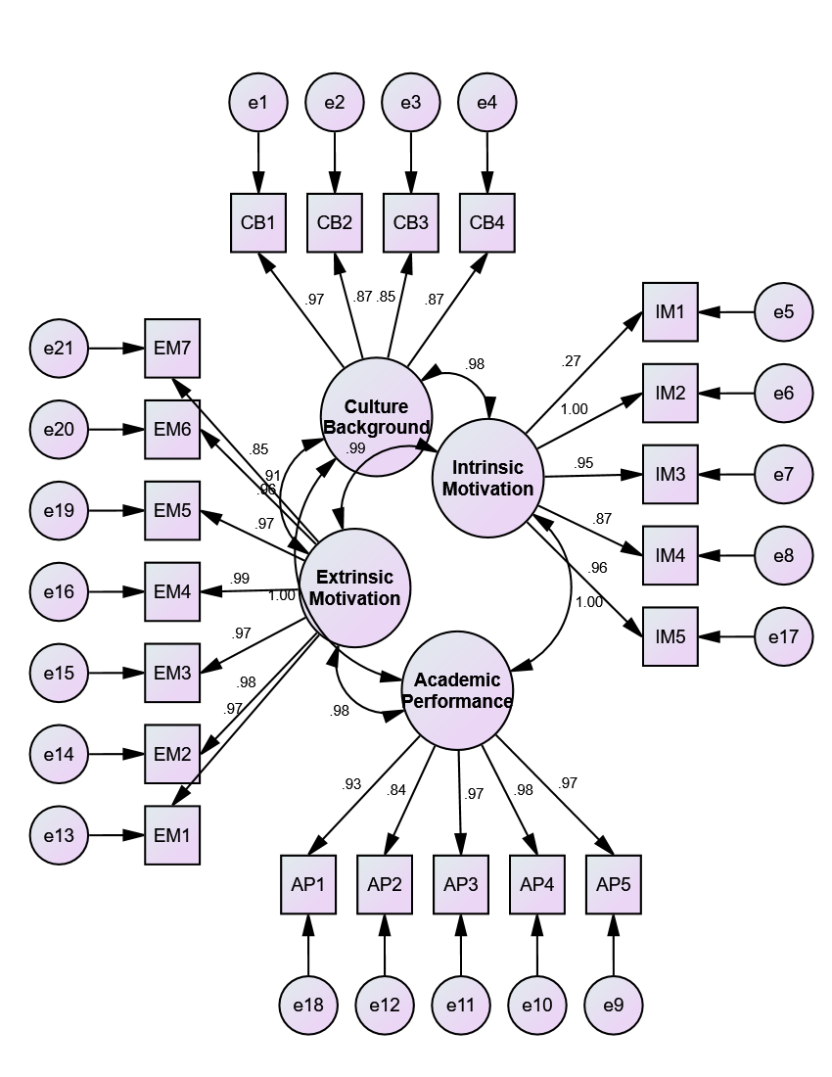

**X2 = 15.02, df = 7, X2/df = 2.14, P = .018, RMR = .02, RMSEA = .067,**

**NFI = .91, GFI = .94, AGFI = .89, CFI = .97**

The models fitness was examined on the basis of fit indices shown as above. The values indicate model is good fitted as all values were found within acceptable range according to Uslu et al., (2008).

**6.4 Regression Model**

Regress model was evaluated in order to determine relationship among dependent variable and independent variables.

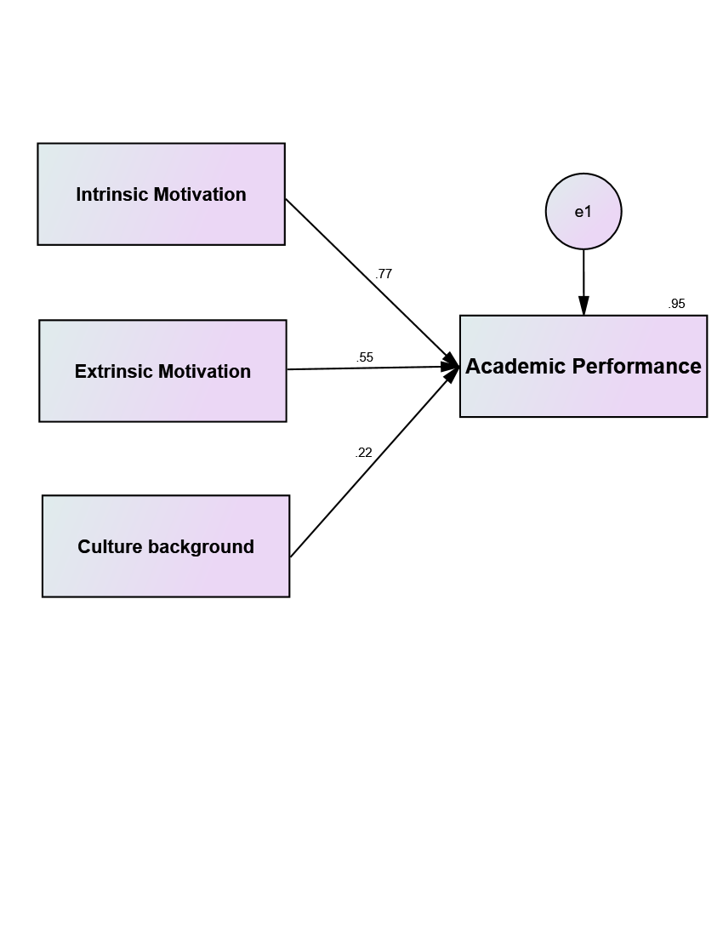

Table 3: *Regress weight*

|  |  |  | **Estimate** | **S.E.** | **C.R.** | **P** |
| --- | --- | --- | --- | --- | --- | --- |
| Academic performance | <--- | Intrinsic Motivation | .063 | .007 | 9.065 | *** |
| Academic performance | <--- | Extrinsic motivation | .539 | .005 | 107.794 | *** |
| Academic performance | <--- | Culture background | .252 | .008 | 31.510 | *** |

The above table presents AMOS regression weight output. The table shows the estimates, standard error (S.E), critical ratio (CR) and “P” the significance level. The CR indicates estimate divided by standard error. The parameter estimate is considered significant at p≤0.05 with C.R values must be greater than 1.96. In above table all significant structural paths between the variables were found significant. The C.R values are 9.065, 107.794 and 31.510 with P values are less than acceptable range 0.05 shown with “***” in table. The study concludes that intrinsic motivation, extrinsic motivation and culture background are significant positive predictor of students’ academic performance. As the “P” value of all variables are less than 0.05.

**7. CONCLUSION AND DISCUSSION**

Motivation is a psychological process that directs an individual to act and behave in a certain way that helps them to satisfy their needs. Indeed in education sector motivation plays a significant role and has a positive association with student achievements. However, motivational factors are fluctuating according to individual personality like desire, need and interest (Tahiroglu & Aktepe 2015) and no universal factor is effective in all situation/level. In this regard, this study was conducted to examine impact of students motivations coupled with culture background on academic performance. For this purpose university students of southern belt HEC recognized university were considered population and stratified random sampling techniques were used for sampling selection. Sample size was 364 calculated based on recommendation of Yamane (1967). The required data was collected through questionnaire adopted from previous study of Vallerand et al., (1992). A total of 364 questionnaires were distributed amongst the targeted participants and 282 were received back. Study found students intrinsic motivation, extrinsic motivation and culture background have significant positive impact on academic performance. Study findings were found consistence with previous research work of Ikhwan et al. (2009) and Auwalu et al., (2014).

This clearly indicates that motivation and culture background serve as a yardstick to enhance academic performance. In this regard, it is recommended that parents and teachers are required to enhance student motivation by engaging them in task oriented activities, coupled with regular counsel to develop their intrinsic motivation that may leads to inculcate reading/writing habit in the students. Moreover, students are to be rewarded on accomplishing of targeted goal, to boost their motivation level.



This work is licensed under a [Creative Commons Attribution 4.0 International License](http://creativecommons.org/licenses/by/4.0/).

## (References)

Aktan, S., & Tezci, E. (2013). Matematik motivasyon ölçeği (MMÖ) geçerlik ve güvenirlik çalışması. *The Journal of Academic Social Science Studies,* 6, 57–77.

Alzahrani SS, Park YS, Tekian A. (2018). Study habits and academic achievement among medical students: A comparison between male and female subjects. Med Teach 40:S1–S9.

Ardenska, A., Tomik, R., Berber, S., Düz, B., Çivak, B., Çalişkan, U., & Ogrodnik, J. (2016). A comparison of physical education students’ motivation using polish and turkish versions of the academic motivation scale. *Journal of Human Kinetics*, *54*(1), 207-218.

Arvidsson, T. S. Y. (2012). *A cross-cultural study of interest, employment opportunities, and motivation among college students* (Doctoral dissertation, San Francisco State University).

Bakar, K. A., Tarmizi, R. A., Mahyuddin, R., Elias, H., Luan, W. S., & Ayub, A. F. M. (2010). Relationships between university students’ achievement motivation, attitude and academic performance in Malaysia. *Procedia-Social and Behavioral Sciences*, *2*(2), 4906-4910.

Barkoukis, V., Taylor, I., Chanal, J., & Ntoumanis, N. (2014). The relation between student motivation and student grades in physical education: A 3‐year investigation. *Scandinavian journal of medicine & science in sports*, *24*(5), e406-e414.

Bates, C. C., D’Agostino, J. V., Gambrell, L., & Xu, M. (2016). Reading recovery: Exploring the effects on first graders’ reading motivation and achievement. *Journal of Education for Students Placed at Risk*, 21, 47–59.

Berndt, T. J., & Miller, K. E. (1990). Expectancies, values, and achievement in junior high school. *Journal of Educational Psychology,* 82(2), 319–326.

Boyle, G. J., Wongsri, N., Bahr, M., Macayan, J. V., & Bentler, P. M. (2020). Cross-cultural differences in personality, motivation and cognition in Asian vs. Western societies. *Personality and Individual Differences*, *159*, 109834.

Burton, K. D., Lydon, J. E., D’Alessandro, D. U., & Koestner, R. (2006). The differential effects of intrinsic and identified motivation on well-being and performance: Prospective, experimental, and implicit approaches to self-determination theory. *Journal of Personality and Social Psychology*, 91, 750–762.

Çelikoz, N. (2010). Basic Factors that Affect General Academic Motivation Levels of Candidate Preschool Teachers. *Education*, *131*(1).

Cerasoli, C.P. and Ford, M.T. (2014), “Intrinsic motivation, performance, and the mediating role of mastery goal orientation: a test of self-determination theory”, Journal of Psychology, Vol. 148 No. 3, pp. 267-286.

Chatzipanteli, A., Digelidis, N., & Papaioannou, A. G. (2015). Self-regulation, motivation and teaching styles in physical education classes: An intervention study. *Journal of Teaching in Physical Education*, *34*(2), 333-344.

Cho, Y.J. and Perry, J.L. (2012), “Intrinsic and employee attitudes: role of managerial trustworthiness, goal directedness, and extrinsic reward expectancy”, Review of Public Personnel Administration, Vol. 32 No. 4, pp. 382-406.

Claver, F., Martínez-Aranda, L. M., Conejero, M., & Gil-Arias, A. (2020). Motivation, Discipline, and Academic Performance in Physical Education: A Holistic Approach from Achievement Goal and Self-Determination Theories. *Frontiers in Psychology*, *11*, 1808.

Dede, Y., & Yaman, S. (2008). A questionnaire for motivation toward science learning: A validity and reliability study. Necatibey Faculty of Education Electronic. *Journal of Science and Mathematics Education*, 2(1), 19–37.

Fortier, M. S., Vallerand, R. J., & Guay, F. (1995). Academic motivation and school performance: Toward a structural model. *Contemporary Educational Psychology*, 20(3), 257–274.

Karaguven, M. H. Ü. (2012). Akademik motivasyon ölçeğinin Türkçe’ye adaptasyonu. *Kuram ve Uygulamada Eğitim Bilimleri*, 12(4), 2599–2620.

Kaufman, J. C., Agars, M. D., & Lopez-Wagner, M. C. (2008). The role of personality and motivation in predicting early college academic success in non-traditional students at a Hispanic-serving institution. *Learning and individual differences*, *18*(4), 492-496.

Kaya, M. F. (2013). Coğrafya öğrenmeye yönelik motivasyon ölçeği geliştirme çalışması. Doğu Coğrafya Dergisi, 30, 155–173.

Kirby, S., Byra, M., Readdy, T., & Wallhead, T. (2015). Effects of spectrum teaching styles on college students’ psychological needs satisfaction and self-determined motivation. *European Physical Education Review*, *21*(4), 521-540.

Kunanitthaworn, N., Wongpakaran, T., Wongpakaran, N., Paiboonsithiwong, S., Songtrijuck, N., Kuntawong, P., & Wedding, D. (2018). Factors associated with motivation in medical education: a path analysis. *BMC medical education*, *18*(1), 140.

Kusnierz, C., Rogowska, A. M., & Pavlova, I. (2020). Examining Gender Differences, Personality Traits, Academic Performance, and Motivation in Ukrainian and Polish Students of Physical Education: A Cross-Cultural Study. *International journal of environmental research and public health*, *17*(16), 5729.

Kusurkar, R. A., Ten Cate, T. J., Van Asperen, M., & Croiset, G. (2011). Motivation as an independent and a dependent variable in medical education: a review of the literature. *Medical teacher*, *33*(5), e242-e262.

Lepper, M. R., Corpus, J. H., & Iyengar, S. S. (2005). Intrinsic and extrinsic motivational orientations in the classroom: Age differences and academic correlates. *Journal of Educational Psychology*, 97(2), 184–196.

Lim, S. Y., & Chapman, E. (2015). Adapting the academic motivation scale for use in pre-tertiary mathematics classrooms. *Mathematics Education Research Journal*, *27*(3), 331-357.

Ludeke, A. K., & Zúñiga, M. C. S. (2017). Educational alignment: Learning–teaching approaches as influencing factors. *Universitas Médica*, *58*(1).

McCabe, K. O., Van Yperen, N. W., Elliot, A. J., & Verbraak, M. (2013). Big Five personality profiles of context-specific achievement goals. *Journal of Research in Personality*, *47*(6), 698-707.

Meece, J. L., & Holt, K. (1993). A pattern analysis of students’ achievement goals. *Journal of Educational Psychology*, 85(4), 582–590.

Muhammad, A. S., Bakar, N. A., Mijinyawa, S. I., & Halabi, K. A. (2015). Impact of motivation on students’ academic performance: a case study of university sultan zainal abidin students. *The American Journal of Innovative Research and Applied Sciences*, *1*(6), 221-226.

Noltemeyer, A., Palmer, K., James, A. G., & Petrasek, M. (2019). Disciplinary and achievement outcomes associated with school-wide positive behavioral interventions and supports implementation level. *School Psychology Review*, *48*(1), 81-87.

Ommering, B. W., van Blankenstein, F. M., Waaijer, C. J., & Dekker, F. W. (2018). Future physician-scientists: could we catch them young? Factors influencing intrinsic and extrinsic motivation for research among first-year medical students. *Perspectives on medical education*, *7*(4), 248-255.

Peklaj, C., & Levpuscek, M. P. (2006). Students’ motivation and academic success in relation to the quality of individual and collaborative work during a course in educational psychology. In *Annual ATEE conference*.

Reeve, J. (2009), Understanding Motivation and Emotion, 5th ed., Wiley, Hoboken, NJ.

Rockich-Winston, N., Train, B. C., Rudolph, M. J., & Gillette, C. (2018). Faculty motivations to use active learning among pharmacy educators. *Currents in Pharmacy Teaching and Learning*, *10*(3), 277-284.

Ryan, R.M. and Deci, E.L. (2000), “Intrinsic and extrinsic motivations: classic definitions and new directions”, Contemporary Educational Psychology, Vol. 25 No. 1, pp. 54-67.

Sevil, J., Abós, Á., Aibar, A., Julián, J. A., & García-González, L. (2016). Gender and corporal expression activity in physical education: Effect of an intervention on students’ motivational processes. *European Physical Education Review*, *22*(3), 372-389.

Shell, K., Holt, E., Kington, A., Mohammed, K., Black, A., Troup, C., ... & Nathaniel, T. I. (2020). Motivation to Learn Neuroanatomy by Cadaveric Dissection is Correlated with Academic Performance. *Clinical Anatomy*, *33*(1), 128-135.

Sobral, D. T. (2004). What kind of motivation drives medical students' learning quests?. *Medical education*, *38*(9), 950-957.

Sockalingam, S., Wiljer, D., Yufe, S., Knox, M. K., Fefergrad, M., Silver, I., ... & Tekian, A. (2016). The relationship between academic motivation and lifelong learning during residency: a study of psychiatry residents. *Academic medicine*, *91*(10), 1423-1430.

Tahiroglu, M., & Aktepe, V. (2015). Validity and reliability study on the motivation scale form designed for 4th and 5th grade social studies course. *International Periodical for the Languages, Literature and History of Turkish or Turkic*, 10(3), 907–932.

Taylor, G., Jungert, T., Mageau, G.A., Schattke, K., Dedic, H., Rosenfield, S. and Koestner, R. (2014), “A self-determination theory approach to predicting school achievement over time: the unique role of intrinsic motivation”, Contemporary Educational Psychology, Vol. 39 No. 4, pp. 342-358.

Vallerand, R. J., Pelletier, L. G., Blais, M. R., Briere, N. M., Senecal, C., & Vallieres, E. F. (1992). The Academic Motivation Scale: A measure of intrinsic, extrinsic, and amotivation in education. *Educational and psychological measurement*, *52*(4), 1003-1017.

Wigfield, A., Eccles, J. S., Schiefele, U., Roeser, R. W., & Davis‐Kean, P. (2011). Development of achievement motivation. *Handbook of child psychology*, *3*.

Wilkinson, T. J., Wells, J. E., & Bushnell, J. A. (2007). Medical student characteristics associated with time in study: Is spending more time always a good thing?. *Medical Teacher*, *29*(2-3), 106-110.

Wolters, C. A., & Rosenthal, H. (2000). The relation between students’ motivational beliefs and their use of motivational regulation strategies. *International Journal of Educational Research*, 33(7), 801–820.

Zimmerman, B. J., & Kitsantas, A. (2014). Comparing students’ self-discipline and self-regulation measures and their prediction of academic achievement. *Contemporary Educational Psychology*, *39*(2), 145-155.

Zimmerman, B. J., Bandura, A., & Martinez-Pons, M. (1992). Self-motivation for academic attainment: The role of self-efficacy beliefs and personal goal setting. *American Educational Research Journal*, 29(3), 663–676.

Zurita-Ortega, F., Badicu, G., Chacón-Cuberos, R., & Castro-Sánchez, M. (2019). Motivational Climate and Physical Activity: A Multigroup Analysis in Romanian and Spanish University Students. *International journal of environmental research and public health*, *16*(11), 2013.